Your First Standalone Component
In this exercise, you will
- Create a standalone Angular component
- Understand the component’s structure
- Use the component selector in the application

- Start a new command window with admin right
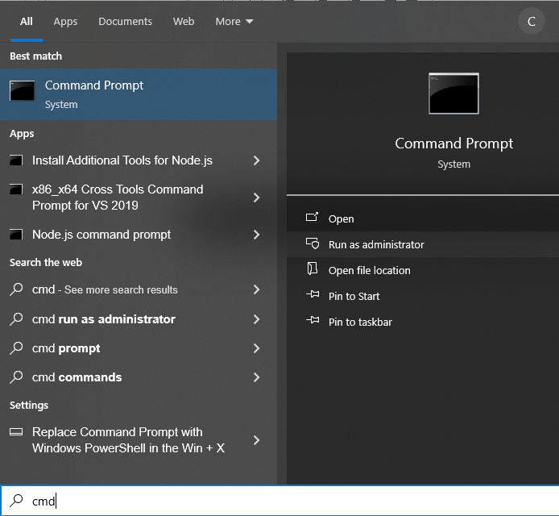

- In the command window, run each of the following commands
  - cd\
  - md Angular
  - cd Angular
  - ng new Ex03 (Use SCSS and the rest settings use default. Wait till ended)
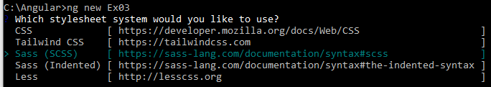
  - cd Ex03
  - code . (There is a space in between code and dot)
Now you should open the Visual Studio Code for your new project folder.
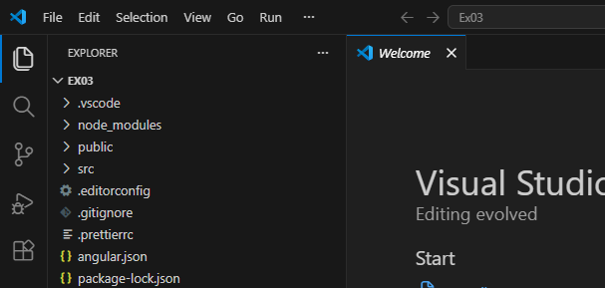
- In VS Code, open a new Terminal Window.

- In the terminal window, run command npm run start
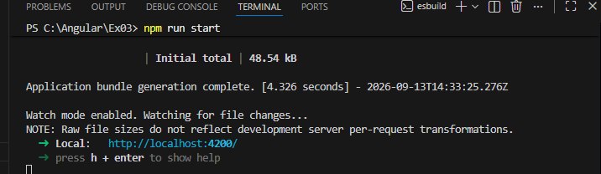
Press ctrl+left mouse click the url http://localhost:4200/

This will start the default web browser for the website
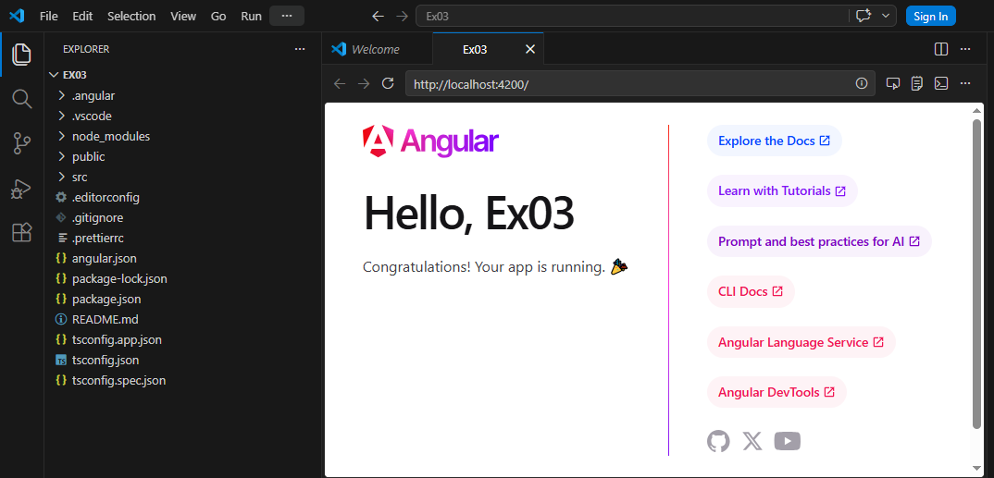
Your website now is up and running under VS Code.

- Open another terminal window
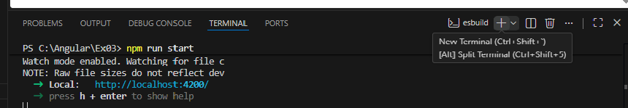
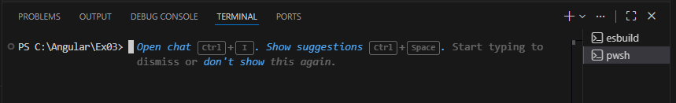
- To generate a new hello component, in the new terminal window, run ng g c hello
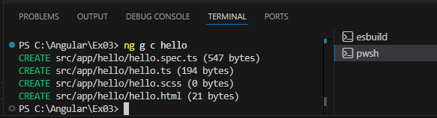

- In the project explorer window, there will be a new hello folder and 4 new files generated
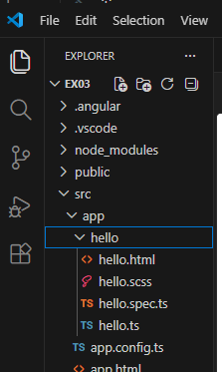

- Change src/app/app.html
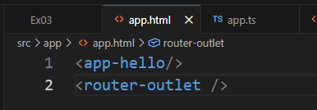

- Need to import the hello component in src/app/app.ts
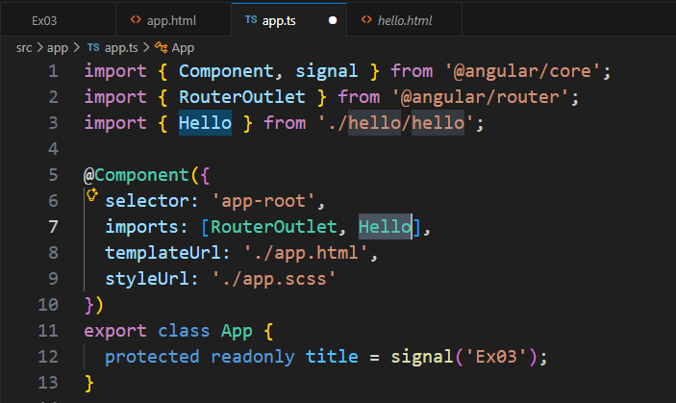
You should also notice that line #3 is added automatically

- In VS Code, Save All Files
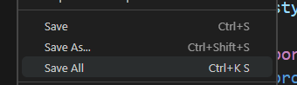

- Back to VS Code, Browser page
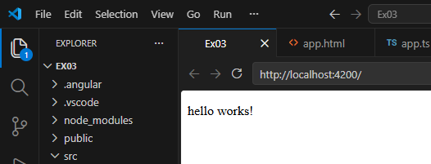
You should be able to see the “hello works!”. This indicated that the component is successfully added.

- In src/app/hello/hello.ts, comment templateUrl, and template
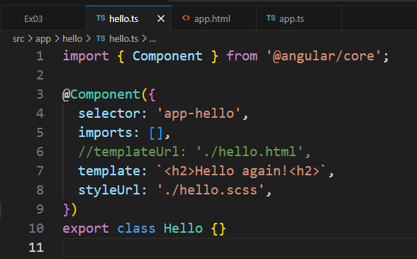

- Save all files and then go back to Browser page
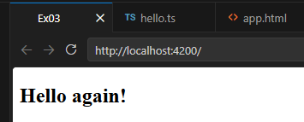

- Close VS Code

